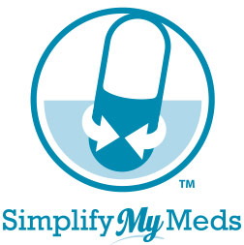
Patient Agreement
We are pleased to welcome you to Simplify My Meds™, our coordinated refill program.

Advantages of participating in the program include:
- Increased convenience—a single monthly trip to the pharmacy.
- Peace of mind from being able to get medications on time and in one order.
- More personal contact with the pharmacist to ask questions and discuss medications.
- Increased understanding of your medication, its purpose, potential side effects and costs.
- Your prescription records will be easily updated to
reflect changes to therapy made by doctors or upon hospital discharge.

I understand the program advantages and the following conditions of participation to achieve the maximum benefits from the Simplify My Meds program.

I hereby agree:
- To accept a phone call each month from the pharmacy to discuss my prescription refills.
- To pick up medications on my assigned refill date (or be available for delivery, if applicable).
- If necessary, to pay an extra co-pay one time for each medication in order to make all refills due on the same day.
- To keep an open dialogue with my pharmacist regarding doctor appointments, hospital/urgent care visits, and changes in my health status.

I have read this document, understand it, and have had all questions answered.

____________________________________________________________________________
Patient Name (please print)

____________________________________________ _______________________
Patient Signature Date

____________________________________________ _______________________
Pharmacist Signature Date

